Name***:***

* Ahmed MohamedBadr
* Mohamed Ibrahem Soliman

Group***:*** SE2

App name*:*Online Bank

**public class {**

**private int Iban;**

**private double Balance;**

**public String toString() {**

**return super.toString()+ "Bank Account{" + "\t Iban=" + Iban + ",\t Balance=" + Balance + '}';**

**}**

**public double getIban() {**

**return this.Iban;**

**}**

**public double getBalance() {**

**return Balance;**

**}**

**public void setBalance(double Balance) {**

**this.Balance = Balance;**

**}**

**public BankAccount(double Balance) {**

**this.Balance = Balance;**

**Random random = new Random();**

**this.Iban = random.nextInt(100000) + 10000;**

**}**

**}**

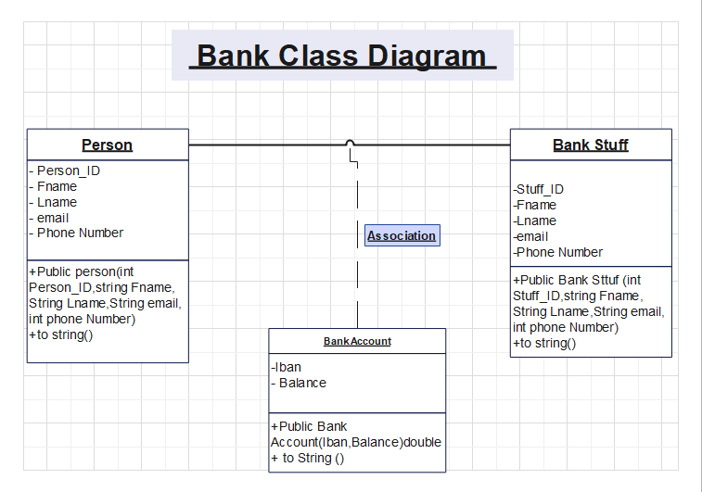

**public class BankSttuff extends Person{**

**private long Person_ID;**

**private ArrayList<Customer> Customer= new ArrayList<Customer>();;**

**public BankStuff( int Person_ID ,String Fname , String Lname, String email, long Phone Number) {**

**super(Person_ID, Fname, Lname, email, Phone Number);**

**Random rand= new Random(); this.Person_ID=rand.nextInt(100000)+100;**

**} public void setCustomer(ArrayList<Customer> Customer) {**

**this.Customer = Customer;**

**}**

**public ArrayList<Customer> getCustomer()**

**{**

**return Customer;**

**}**

**public void AddCustomer(Customer CustomerPhoneNumber){**

**Customer.add(CustomerPhoneNumber);**

**System.out.println("Customer Added!");**

**}**

**public void remove Customer(Customer CustomerPhoneNumber){**

**Customer.remove(CustomerPhoneNumber);**

**System.out.println("Customer removed!");**

**}**

**public long getPerson_ID(){**

**return Person_ID;**

**}**

**@Override**

**public String toString() {**

**return "BankSttuf{" + "\n Person_ID=" + Person_ID +"\nCustomer: "+this.getCustomer()+ '}';**

**}**

**}**

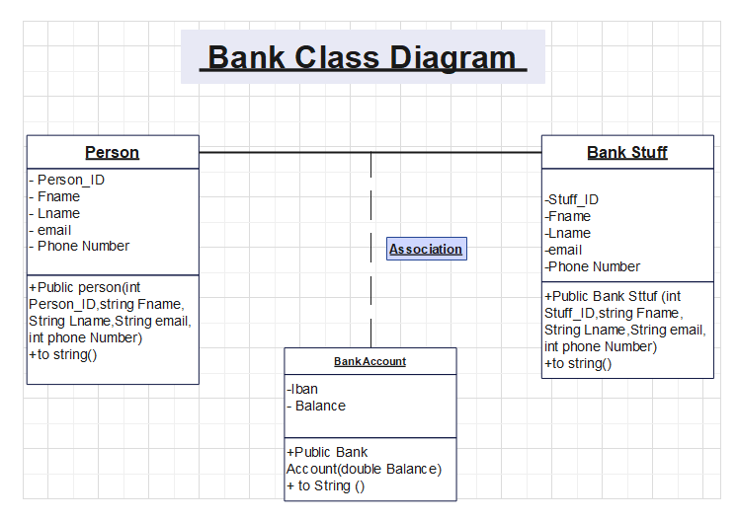

**public class Person {**

**private int Person_ID;**

**private String Fname, Lname, email;**

**private long Phone Number;**

**public Person( int Person_ID, String Fname, String Lname, String email, long Phone Number) {**

**this.Person_ID =Person_ID;**

**this.Fname = Fname;**

**this.Lname = Lname;**

**this.email = email;**

**this.Phone Number = Phone Number;**

**}**

**public String getPerson_ID() {**

**return ad;**

**}**

**public void setPerson_ID(String Person_ID) {**

**this.Person_ID = Person_ID;**

**}**

**public String getFname() {**

**return ad;**

**}**

**public void setFname(String Fname) {**

**this.Fname = Fname;**

**}**

**public String getLname() {**

**return Lname;**

**}**

**public void setLname(String Lname) {**

**this.Lname = Lname;**

**}**

**public String getemail() {**

**return email;**

**}**

**public void setemail(String email) {**

**this.email = email;**

**}**

**public long getPhoneNumber() {**

**return PhoneNumber;**

**}**

**public void setPhoneNumber(long PhoneNumber) {**

**this.PhoneNumber = PhoneNumber;**

**}**

**@Override**

**public String toString() {**

**return "Person{" +"\nPerson_ID="+Person­­­_ID +", "\n Fname=" + this.Fname + ", \n Lname=" + this.Lname + ", \n email=" + this.email + ", \n PhoneNumber=" + this.PhoneNumber + '}';**

**}**

**}**

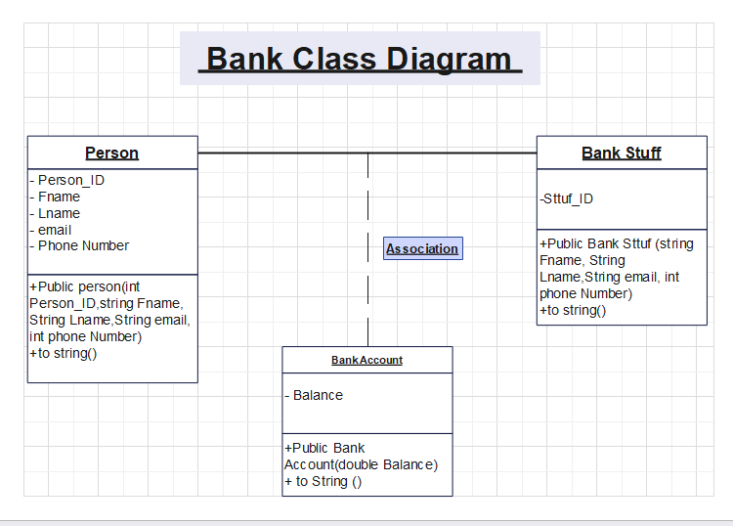

**Description:**

In the person class, there are common features that bank personnel and customers can have.   
  
The figure shows the properties that this class can have. The BankStaff and Customer classes inherit from the Person class. The properties that must be present in the BankStuff class are shown in the figure. In this class, create an ArrayList named customers to store the customers represented by the bank staff. Relevant customer objects will be stored in this ArrayList, design accordingly.should add to ArrayList. The delete account method should first check the balance of the account, if the account balance is greater than 0, it should display the warning "please transfer your balance to another account first". If it is equal to 0, delete the account. CreditCardDelete method should first check the current debt information of the card, if it is equal to 0, it should delete the card, otherwise "please pay the debt first".

**Reference:**

https://github.com/SabaUrgup/online-BankApp